**ProP**

Table of Contents

**Project Statement** **3**

**Client** **3**

**Project leader** **3**

**Initial situation** **3**

**Problem description** **3**

**Project goal** **4**

**Project deliverables and non-deliverables** **4**

**Deliverables** **4**

**Non-deliverables** **4**

**Project constraints** **5**

**Project risks** **6**

**Project phasing** **7**

**Phase 1: Initiation** **8**

**Phase 2: Definition** **8**

**Phase 3: Design** **9**

**Phase 4: Build** **10**

**Phase 5: Test** **11**

**Phase 6: Deployment** **12**

**Gantt Chart** **13**

**WBS** **14**

# Project Statement

In this chapter we will describe how our project started and what the end goals are. The following topics will be described in this chapter: the client, the project leader, the initial situation, the problem description, the end goal of our project, the project’s deliverables and non-deliverables, the project constraints and as last the project risks.

## Client

The client we will be working with is the company called StageBrite. The person they’ve assigned as our contact person is a Mr. Henning.

**Contact Information:**

Name: Frank henning

Phone number: +(31) 612208921

E-mail: f.henning@fontys.nl

## Project leader

The team leader is Mr. Baghban who has experience in software development and project management. Working alongside is:

Mr. Hamidi, Mr. Gael and Mr. Hermelijn.

**Contact Information:**

Name: Mohammad Reza Baghban

Phone number: +(31) 668526426

Email: [Mrbhmr@gmail.com](mailto:Mrbhmr@gmail.com)

## Initial situation

StageBrite is hosting an event named “Highlands Halloween Festival”. It’s a Halloween Spooktacular where you get to eat, play and be scary. The event will offer activities such as games, dancing, a photo booth and more.

## Problem description

StageBrite’s popularity has increased a lot lately which directly reflects on the scale of the events they organize. Currently they are using papers tickets which is inefficient for a large scale event. Therefor they need a software solution which will allow them to automate a big part of the event. Making it an easier and a more systematic way to manage the event.

## Project goal

This project’s goals are:

1- Creating a website that allow the user to view, buy/cancel tickets and top up/check balance of their event account.

2- Creating a C# application for the administrators for the entrance of the event and for the store that sells/loans products.

## Project deliverables and non-deliverables

### Deliverables

* A chosen name and designed logo for our team
* A project plan
* A setup document
* A process report
* A universal C# application that can be utilized in all following situations:
  + Entrance validation at the gate
  + Entrance/Exit validation at the camping sites
  + Manage purchases at the store
  + Manage orders for loaning products at the loaning stand
  + Manage office to perform following tasks:
    - Check the status of the event
    - Convert the information in the transaction-log-file to the database
* A fully functional Website:
  + Users can view the event schedule and possible ticket types(1-3 day tickets)
  + Buy tickets for the event depending on the number of days they wish to attend
  + Cancel a bought ticket
  + A dashboard for users to see their tickets, group members(if it’s a group) and view the balance on their accounts .
* A presentation about project

### Non-deliverables

* The communication proof of team members.
* Maintenance after the final evaluation would be done by client

## 

## 

## Project constraints

* **Time**

The duration for the project is 4 months.

* **Budget**

The total allocated budget for this project is: ***50000€*** euros. This will be divided into:

* 1400 man hours at a rate of 28 euros per hour.
* 4000€ for software & hardware related costs.
* 4000€ for any possible risk
* 2000€ for marketing related costs
* **Application’s Language**

The language of the application will be in English due to the target audience of the client.

* **Programming Language**

The programming languages that we will use are:

* C# for the user interface
* SQL for the database
* HTML, Php, JavaScript and CSS for the website

# Project risks

|  |  |  |  |  |
| --- | --- | --- | --- | --- |
| **Risks** | **Probability** | **Impact on the project** | **Prevention** | **Action** |
| 1.The program has minor bugs that affect the operation of the application | Low | Medium | create a test plan to test the program and find as many bugs as possible. | Try to identify the error and fix the bug as soon as possible before delivering the first version which has to meet the client requirements. |
| 2.Incapability to finish on time | Low | High | Follow the project phasing and schedule as close as possible and have bi-weekly meeting. | Negotiate to push the deadline back  Try to work before clock. |
| **3.** The client asks for changes in the project requirements | low | High | request the client to analyze the project plan and the setup document carefully and to inform us of any prefered changes prior to the commencement of the project. | Arrange a meeting with the client. Then, modify the application to meet the client expectation if possible . |
| **Limited resources to complete project** | Low | High | Create a work breakdown structure and specify where our funds will be going towards. | Negotiate with the client for lower requirements or sacrifice the quality of the product to match resources. |

# Project phasing

In this second chapter, it is described how our team will work on this project step by step, milestone by milestone. In the visual below the phases of our project with activities and milestones and their dependencies to each other are all represented where you can see an overview our activities, the phases they occur in and the milestones we’ve decided on. This project will last 20 weeks to be completed. The critical path is shown with bright pink border on lasting activities in building phase

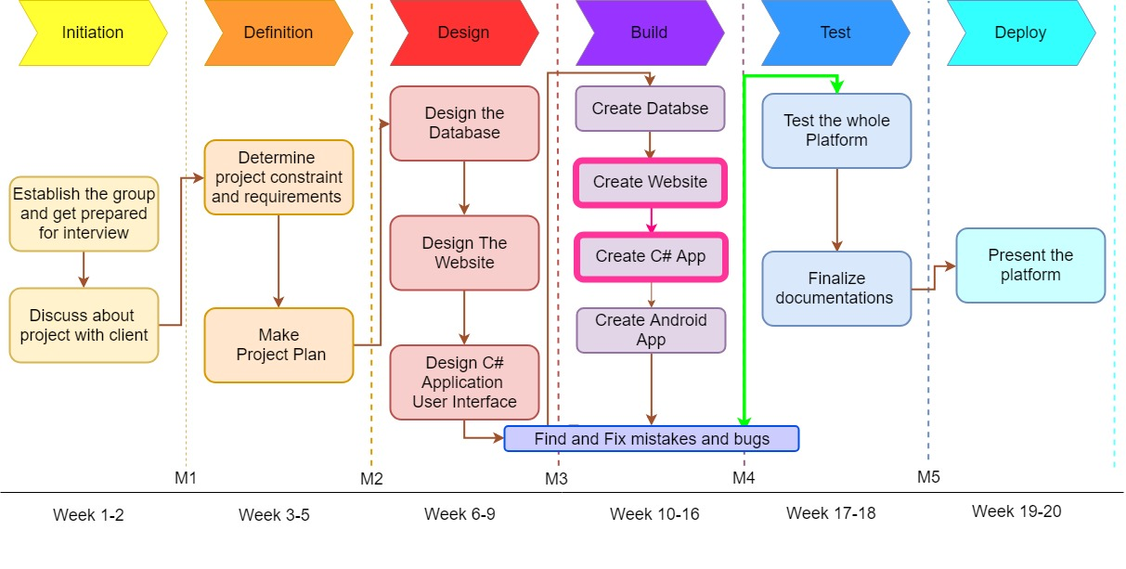

## Phase 1: Initiation

During this first phase, the project’s objective is identified.

Activity: Establish the group and get prepared for the interview:

Tasks for this activity are:

* Establish group and choose participants
* Choose group leader of team
* Choose a name for group
* Design a logo for group
* Create a time schedule for group meeting
* Read the project workbook (1.5 * 4 = 6 Hours)
* Evaluate provided information upon project
* Make Question for interview with client

Estimated duration is 1 week and 32 man hours

Activity: Discuss about the project with the client

Tasks for this activity are:

* Participate in Kick-off Meeting ( 2 * 4 = 8 Hours)
* Arrange meeting with the client
* Interviewing the client and share questions with him
* Discuss the current situation, the problems, and the desired end results.
* Define each task for each team member (project leader, specialist, etc.).
* Evaluating similar solutions on the market by team members
* Design and create WBS(Work breakdown Structure) (4 Hours)
* Define the project phasing (2 Hours)

Estimated duration is 1 week and 20 man hours.

Deliverables for milestone M1 are:

* A name and logo for the group
* Work breakdown structure

## Phase 2: Definition

During this second phase, we will define the needed requirements for the remaining phases.

Activity: Make the first draft of Project Plan

Tasks for this activity are:

* Design outline and structure of Project Plan for Client
* Explain the initial situation
* Provide problem description
* Determine (non)deliverables
* Determine Constraint and Risks
* Scheduling the outline of project phasing

Estimated duration: 2 weeks and 64 Hours

Activity: Discuss the constraints and requirements of the apps and website.

Tasks for this activity are:

* Make a choice on which programming language we’re going to be used to make the apps.
* Make a choice on which framework we’re going to use for the website.
* Make a choice on which modeling tool we’re going to use for the data model of the database.
* Make some investigation upon which means of identification should be chosen
* Provide first draft of setup document
* Revise and provide final version of Project Plan

Estimated duration is 1 weeks and 32 man hours.

Deliverables for milestone M2 are:

* The programming language that’s going to be used for the apps.
* The framework that’s going to be used for the website.
* The modeling tool we’re going to use for the data model of the database.
* Final version of project plan
* Draft of the setup document

## 

## Phase 3: Design

During this third phase, we have 2 major activities: Making the design of the website and making the design of the user interfaces of the C# applications. For these activities, the tasks are described below.

Activity: Design the website

Tasks for this activity are:

* Look at websites which have the same use case for inspiration
* Look at website templates for inspiration.
* Create the wireframe of the website

Estimated duration is 1 week and 32 man hours.

Activity: Design the user interfaces for the C# applications

Tasks for this activity are:

* Think about the requirements which need for the user interface.
* Make an initial draft of the user interface
* Once the design has be finalized, different iterations will be made from it with each their own exclusivity.
* Write pseudocode to make the next phase easier

Estimated duration is 1 week and 32 man hours.

Activity: Design the database

Tasks for this activity are:

* Make the tables for the database
* use normalization to convert them into an ERD.
* Convert the ERD into a data model
* Make a database design based on the data model

Estimated duration is 1 weeks and 32 man hours

Deliverables for milestone M3 are:

* The website’s design
* The C# app’s design
* The database’s data model
* Setup Document

## Phase 4: Build

For this next phase we will describe how functionality will be added to the items that were mentioned in the design phase.

Activity: Create the database

Task for this activity is:

* Recheck the structure of database
* Transfer the data model into the database design
* Create actual database using MySQL

Estimated duration is 13 days and 45 man hours

Activity: Create the website

Tasks for this activity are:

* Create the web structure using HTML
* Create the website’s style using CSS
* Implement the required JavaScript
* Create a login/register system using PHP
* Connect website to the database

Estimated duration is 3 weeks and 96 man hours

Activity: Create the C# application

Tasks for this activity are:

* Recreate the pseudocode in working code
* Create test applications of each of the applications required
* Create a connection between the database and the applications
* Place all the applications in a tabular layout

Estimated duration is 3 weeks and 96 man hours

Activity: Create simple Android Application for taking simple log

* Create an android application for event organizer that can take retrieve the whole revenue of the event in simple chart(s)

Estimated duration 1 Week and 32 Hours

Deliverables for milestone M4 are:

* The website
* The database
* The C# applications
* Simple Android Application

## Phase 5: Test

In this phase we will test our deliverables from phase 4 in order to see if they work properly or not. If they do not work correctly, we will be forced to go back to the 4th phase in order to correct our mistake(s).

Activity: Test the deliverables from phase 4

Tasks for this activity are:

* Research methods that would prove beneficial in testing the phase 4 deliverables
* Divide the team in 3 groups that will conduct the tests
* Record all results in a test report

This activity will run in parallel with the activities of phase 4

Activity: Finalizing project documentation

Tasks for the activity are:

* Finalize test plan
* Finalize test report
* Finalize process report

Estimated duration is a week and 32 man hours.

Deliverables for milestone M5 are:

* Test plan
* Test report
* Process Report

## 

## Phase 6: Deployment

In this final phase we will present the deliverables from phase 4 tested. We have to give a presentation about the deliverables and incorporate a demo in the presentation itself.

Activity: Final stretch

Tasks for this activity are:

* Prepare the demo for the client
* Prepare the presentation

Estimated duration is 1 week and 10 man hours

Deliverables for milestone M6 are:

* The website
* The database
* The C# applications
* Presentation

# Gantt Chart

# 

# 

# 

# 

# 

# 

# 

# 

# WBS

